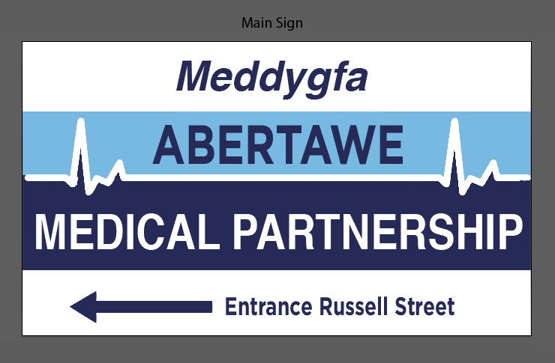

**How We Use Your**

**Health Records**

**This leaflet explains:**

* Why the NHS collects information about you and how it is used.
* Who we may share information with.
* Your right to see your health records and how we keep your records confidential.

**Why we collect information about you:**

In the National Health Service we aim to provide you with the highest quality of healthcare. To do this we must keep records about you which contain information recorded by health workers who have been involved with your care.

**What records about you do we keep?**

* Basic details about you such as address, date of birth, next of kin;
* Contact we had with you such as clinical visits;
* Notes and reports about your health;
* Details and records about your treatment and care;
* Hospital letters;
* Results of x-rays, laboratory tests, etc;
* Relevant information from people who care for you and know you well such as health professionals and relatives.

**It is good practice for people in the NHS who provide care to:**

* Discuss and agree with you what they are going to record about you and if you ask, show you what they have recorded about you.

**How we keep your records confidential**

* Everyone working for the NHS has a legal duty to keep information about you confidential and this practice retains your information securely;
* We will only as for and keep information that is necessary. We will keep it as accurate and as up-to-date as possible. We will explain the need for any information that we ask for if you are not sure why it is needed;
* To help us protect your confidentiality it is important to inform us about any relevant changes that we should know about. This would include such things as change of personal circumstance, change of address/phone numbers;
* All persons in the practice (not already covered by a professional confidentiality code) sign a confidentiality agreement that explicitly makes clear their duties in relation to personal health information and the consequences of breaching that duty;
* Access to patient records by staff other than clinical staff is regulated to ensure that they are used only to the extent necessary to enable tasks to be performed for the proper functioning of the practice. In this regards, patients should understand that practice staff may have access to their records for:
  + Identifying and printing repeat prescriptions for patients. These are then reviewed and signed by a GP
  + Generating a medical certificate for the patient. This is then checked and signed by a GP
  + Typing referral letters to hospital consultants or allied health professionals such as physiotherapists, occupational therapists, psychologists and dietitians.
  + Opening letters from hospitals and consultants. The letters could be appended to a patient’s paper file or scanned to their electronic patient record.

**We have a duty to**

* Maintain full and accurate records of care we provide to you
* Keep records about you confidential and secure
* Provide information in a format that is accessible to you (e.g large type if you are partially sighted)

**What information about you do we share?**

The reason we share your information is solely for the purpose of your direct care. There are currently two ways this can be processed.

**Benefits of sharing information**

Sharing information can help improve understanding, locally and nationally, of the most important health needs and the quality of the treatment and care provided by local health services. It may also help researchers by supporting studies that identify patterns in diseases, responses to different treatments and potential solutions.

Information will also help to:

* Guide local decisions about changes that are needed to respond to the needs of local patients;
* Support public health by anticipating risks of particular diseases and conditions, and help us take action to prevent problems;
* Improve the public’s understanding of the outcomes of care, giving them confidence in healthcare services;
* Guide decisions about how to manage NHS resources fairly so that they can best support the treatment and management of illness for the benefit of patients.

**Summary Care Record**

A Summary Care Record will, in its basic form, contain important information about any medicines you are taking, allergies you suffer from and any bad reactions to medicines that you have had.

Giving healthcare staff access to this information can prevent mistakes being made when caring for you in an emergency or when your GP practice is closed. Your Summary Care Record will also include data to uniquely identify you correctly.

You can also ask your practice to include additional information such as current conditions on your SCR. It is very straight forward to add but we can only do this with your express permission.

**GP clinical system**

From time to time it is helpful for us to be able to share information about your health and care requirements with other health organisations that are responsible for your health care. Work has been ongoing to improve the way that medical records are made available to treating clinicians nationally. As a result of this work we are now able to share clinical information between health professionals including other GP Practice, child health services, community health services, hospitals, out of hours, palliative care and similar.

Sharing information in this way is designed to ensure that the healthcare professional looking after you has the most relevant information to enable them to provide you with the most appropriate care. The type of information shared includes a summary of current problems, current medication, allergies, recent rests, diagnosis, procedures, investigations, risks and warnings – all information is currently held in your GP record (unless marked as private).

**Other Agencies**

The NHS may not be the only government service to provide you with the care that you need. It may be necessary for us to provide information to other agencies directly involved in your care. Under these circumstances we will seek your consent before information is shared.

We may request your specific consent to use personal information in research projects or other non-medical aspects of treatment. If you do not wish your information/medical records to be accessed for such a purpose then please inform a member of staff.

**Can you ask for your information not to be shared?**

You can ask for any information and/or consultation to be marked as **private**. This means that viewing this particular information and/or consultation is restricted to staff (clinical and non-clinical) in the practice, but allows the rest of the record to be viewed by whoever is treating you. It is your responsibility to tell us if there is any information that you wish to be marked as private.

**Can I change my mind?**

**Yes**, you can always change your mind and amend who you give consent to see your records.

For instance, you can decline to share your records out from the surgery, but if you build up a relationship with the physiotherapist who was treating you and they ask you if they could look at an x-ray report, you could give your consent at that point for them to view your records.

You will be referred back to us to change your preference, so the physio treating you should – with your permission – be able to see your records by the time of your next appointment.

**If I decline – what happens in an emergency?**

In the event of a medical emergency, for instance you were taken unconscious to A+E, and the clinician treating you feels it is important to be able to see your medical records, he/she will be able to override any consents set.

However, the doctor has to give a written reason for doing so.

**Access to your records?**

The Data Protection Act 1998 gives every living person, or an authorised representative, the right to apply for access to their health records. You have a right to ask for a copy of your records held about you. We are required to respond within 40 working days, however we will do our best to complete your request in a shorter timescale.

You will be required to request a copy of your medical notes in writing and will need to provide adequate information (for example, full name, date of birth and address). You will be required to provide identification before any information is released to you.

If you think of anything factually inaccurate or incorrect, please inform your GP.

**Can anyone else see my medical records?**

Not unless you give your written consent for this to happen.

On a daily basis, we get requests for insurance companies to either have copies of medical records or excerpts from patients’ medical records. This requires your signed consent as it has not been requested to treat/care for you.

Occasionally we are asked for information from the records for legal reasons; again, this has to be done with your written consent, or in very exceptional cases, by court order.

**Any questions?**

If you have any queries then please speak to a receptionist. If they feel necessary, they can ask another member of the team to give you a call.

For more information, including a list of frequently asked questions (FAQs), please go to the website at [www.nhs.uk/caredata](http://www.nhs.uk/caredata).

You can also get further information from the website at [www.hscic.gov.uk](http://www.hscic.gov.uk).

**WE HOLD YOUR RECORDS IN STRICT CONFIDENCE.**